**Exercise 2: Implementing Dependency Injection**

**Scenario:**

In the library management application, you need to manage the dependencies between the BookService and BookRepository classes using Spring's IoC and DI.

**Steps:**

1. **Modify the XML Configuration:**
   * Update **applicationContext.xml** to wire **BookRepository** into **BookService**.
2. **Update the BookService Class:**
   * Ensure that **BookService** class has a setter method for **BookRepository**.
3. **Test the Configuration:**
   * Run the **LibraryManagementApplication** main class to verify the dependency injection.

<?xml version="1.0" encoding="UTF-8"?>

<beans xmlns="http://www.springframework.org/schema/beans"

xmlns:xsi="http://www.w3.org/2001/XMLSchema-instance"

xmlns:context="http://www.springframework.org/schema/context"

xmlns:aop="http://www.springframework.org/schema/aop"

xsi:schemaLocation="

http://www.springframework.org/schema/beans

http://www.springframework.org/schema/beans/spring-beans.xsd

http://www.springframework.org/schema/context

http://www.springframework.org/schema/context/spring-context.xsd

http://www.springframework.org/schema/aop

http://www.springframework.org/schema/aop/spring-aop.xsd">

<aop:aspectj-autoproxy/>

<context:component-scan base-package="com.library" />

<bean id="bookRepository" class="com.library.repository.BookRepository" />

<bean id="bookService" class="com.library.service.BookService">

<constructor-arg ref="bookRepository"/>

<property name="bookRepository" ref="bookRepository" />

</bean>

<bean id="loggingAspect" class="com.library.aspect.LoggingAspect" />

</b

**package** com.library.service;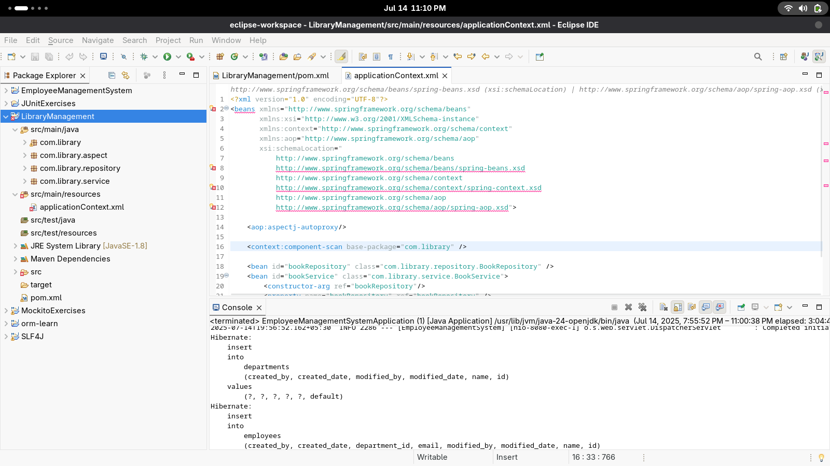

**import** com.library.repository.BookRepository;

**import** org.springframework.stereotype.Service;

**import** org.springframework.beans.factory.annotation.Autowired;

@Service

**public** **class** BookService {

@Autowired

**private** BookRepository bookRepository;

**public** BookService(BookRepository bookRepository) {

**this**.bookRepository = bookRepository;

}

**public** **void** setBookRepository(BookRepository bookRepository) {

**this**.bookRepository = bookRepository;

}

**public** **void** addbook(String name) {

bookRepository.book(name);

System.***out***.println("Book added" + name);

}

}

**package** com.library;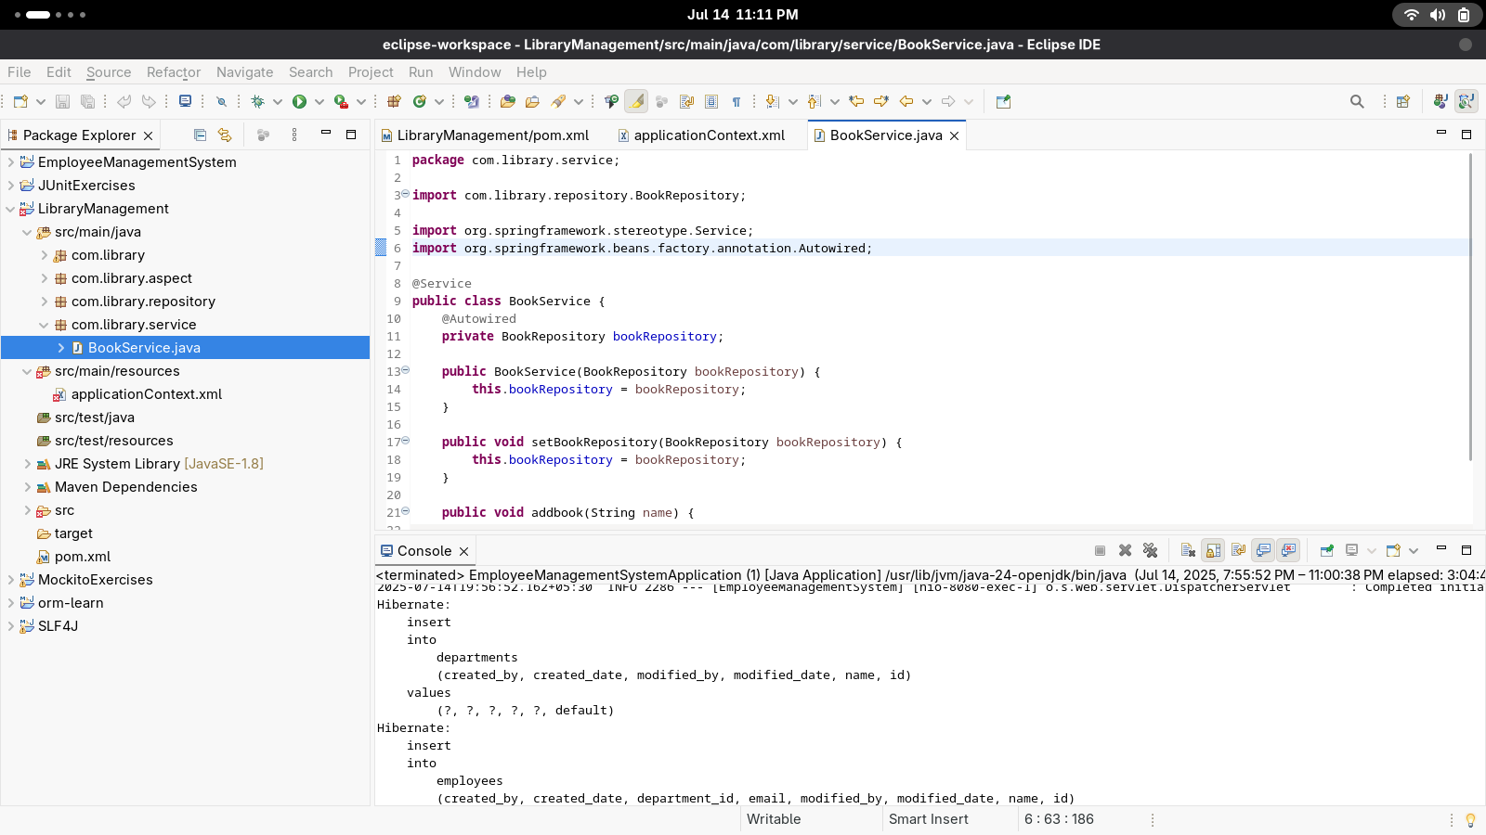

**import** org.springframework.context.ApplicationContext;

**import** org.springframework.context.support.ClassPathXmlApplicationContext;

**import** com.library.service.BookService;

**public** **class** main {

**public** **static** **void** main(String[] args) {

ApplicationContext context = **new** ClassPathXmlApplicationContext("applicationContext.xml");

BookService bookService = (BookService) context.getBean("bookService");

bookService.addbook("The Hobbit");

}

}

Output: 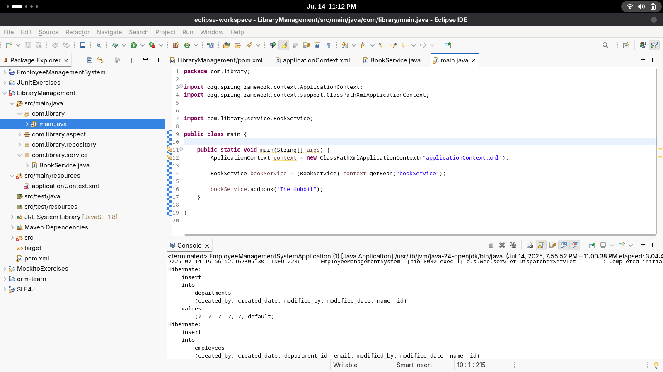

Before methodaddbook

Book nameThe Hobbit

Book addedThe Hobbit

After methodaddbook

void com.library.service.BookService.addbook(String)executed in 24

